Putnam County Hospital Partners with Putnam County Health Department and DePauw to Set Plans in Place for COVID-19

On Wednesday, March 11, 2020 members of the Putnam County Health Department, representatives from DePauw, and Putnam County Hospital faculty joined forces to host a teleconference for area stakeholders and businesses. The teleconference had over 60 members from local healthcare facilities, first responders, schools, elected officials, and business owners. The goal of the call was to discuss precautionary measures to ensure that our community is prepared for a potential outbreak related for COVID-19.

Vicky Trusler, PCH Infection Preventionist, provided those on the webinar with background information related to the Human coronaviruses. Although COVID-19 is similar to the other types of coronaviruses, it is unique in many ways and we are still learning more each day. COVID-19 is spread by close person-to-person contact from droplets from a cough or sneeze, which can get into your mouth, nose, or lungs. Close contact is defined as being within approximately 6 feet of another person. Trusler went on to explain that 80% of people with covid-19 have a mild form of the disease (cold or flu like symptoms). The population most likely to become seriously ill are those over the age of 60 and those with pre-existing health conditions.

Dr. Robert Heavin, Lisa Zeiner, and Sara Burnett, RN provided the group with an update from the Health Department perspective. The Putnam County Health Department has either emailed, mailed, or hand delivered education material to all area schools, health care facilities, law enforcement agencies, EMS, and Long Term Care Facilities. They will continue to work to Prevent, Promote, and Protect the community of Putnam County. The Putnam County Health Department is going to continue to be the first line of defense for our community. The health department will be notified by ISDH first of any suspected or confirmed case of COVID-19 in our community. They will continue to work with Health care providers, Schools, EMS, Law Enforcement, etc. as we monitor COVID-19. They will continue to be in contact on a daily basis with the Indiana State Health Department.

Putnam County Hospital gave detailed information to the group outlining necessary steps the community would need to take in the event they need to seek testing for the COVID-19 virus. Those being: after confirmation from ISDH, call ahead to 765-301-7300, stay in your vehicle, wait for a staff member to provide you with personal protective equipment, they will be in personal protective equipment gear as well. They will take you to the designated testing room, the specimen will be collected and the individual will be asked to return home to self-isolate, if they are not experience serious symptoms.

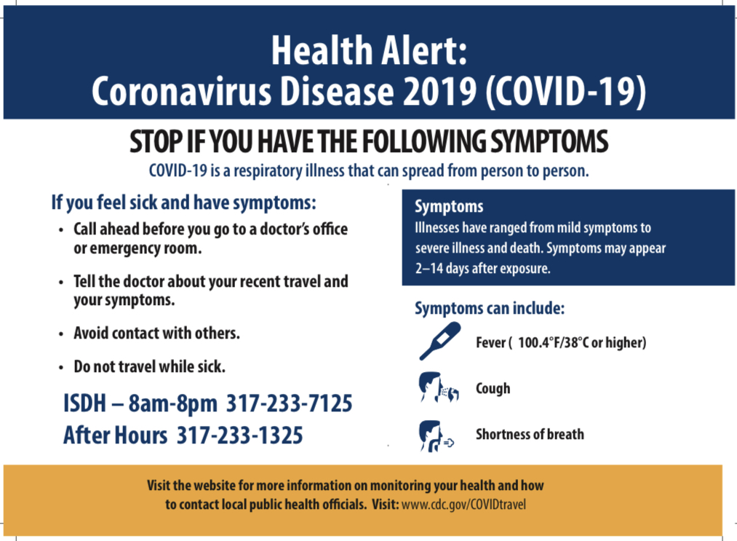
DePauw University representatives from the Critical Incident Management Team and DePauw Health medical director Dr. David Harsha, addressed the group by giving an update on the students and faculty of DePauw. For updates on DePauw’s COVID-19 planning, please visit their website at depauw.edu/preparedness/.

At this point the Putnam County Health Department can give best practices recommendations and guidelines, but cannot make private group policy decisions. Please seek out advice from the CDC.gov website as they continuously update related to the travel advisory.

COVID-19 is spread by close person to person contact from droplets from a cough or sneeze. The incubation period for COVID-19 is anywhere from 2-14 days. However, most develop symptoms 5-8 days after exposure. The CDC guidelines state: positive patients must be isolated for 14 days and must have 2 consecutive negative tests before isolation is discontinued. Therefore, it is imperative that individuals remember that there are many things that can be done to avoid COVID-19 and keep it from spreading. Wash your hands often with soap and water for at least 20 seconds. If soap and water are not available, use an alcohol-based hand sanitizer with at least 60% alcohol. Don't touch your eyes, nose, or mouth, especially with unwashed hands. Avoid close contact with people who are showing symptoms of illness. Clean and disinfect frequently touched objects and surfaces. Cover your cough or sneezes with a tissue or sneeze into your elbow. Throw the tissue in the garbage and make sure to clean your hands afterwards. Stay home when you are sick.

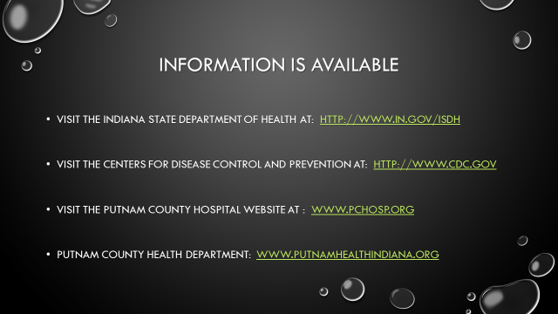

Putnam County Hospital; providing exceptional healthcare close to home.

